Department of Electrical Engineering
The Superior University, Lahore

Computer Programming

Experiment No.7
Practicing Pattern Programming Using Nested Loops

Prepared for:
EISHA NAWAZ
By:
Name: Tanseer Haider
ID: SU91-BSEEM-F25-002
Section: Electrical Engineering Fall 25
Semester: 2nd

Total Marks: ______10_________
Obtained Marks: ______________
Signature: __________________
Date: __________________

Experiment No.7
Practicing Pattern Programming Using Nested Loops
(Rubrics)

Name: Tanseer Haider ID: SU91-BSEEM-F25-002

- PSYCHOMOTOR
Serial No. | Criteria | Allocated Marks | Unacceptable  0% | Poor  25% | Fair  50% | Good  75% | Excellent  100% | Total Obtained
1 | Syntax Handling | 1 | 0 | 0.25 | 0.5 | 0.75 | 1
2 | Program Coding Skills | 2 | 0 | 0.5 | 1 | 1.5 | 2
3 | Accuracy in Output Results | 3 | 0 | 0.75 | 1.5 | 2.25 | 3
Sub-Total |  | 6 | Sub Total Marks Obtained in Psychomotor (P)

- AFFECTIVE
Serial No. | Criteria | Allocated Marks | Unacceptable  0% | Poor  25% | Fair  50% | Good  75% | Excellent  100% | Total Obtained
1 | Lab Report | 2 | 0 | 0.5 | 1 | 1.5 | 2
2 | Assigned Task | 2 | 0 | 0.5 | 1 | 1.5 | 2
Sub-Total |  | 4 | Sub Total Marks Obtained in Affective (A)

Instructor Name: | EISHA NAWAZ | Total Marks (P+A): | ____10_________
Instructor Signature: | ______________ | Obtained Marks (P+A): | ______________
Contents of Lab 7
1 Objectives 4
2 Nested Loops 4
2.1 Types of Nested Loops 4
2.2 Structure of For Loop 4
2.3 Example 1 5
2.4 Example 2 5
3 Lab Tasks 6
3.1 Task 1 6
3.2 Task 2 6
3.3 Task 3 6
3.4 Task 4 7
3.5 Task 5 7
3.6 Task 6 7
4 Home Assignment: 8
4.1 Task 1 8
4.2 Task 2 8
4.3 Task 3 8
4.4 Task 4 8

Practicing Pattern Programming Using Nested Loops

Objectives
- To get basic understanding of nested loops.
- To practice how to use the nested loops.
- Where and when to use ‘nested for loop’.
- To get basic understanding of switch statement.
- To get hands on experience working with for loops

Nested Loops
A loop inside another loop is called a nested loop. The depth of nested loop depends on the complexity of a problem. We can have any number of nested loops as required. Consider a nested loop where the outer loop runs n times and consists of another loop inside it. The inner loop runs m times. Then, the total number of times the inner loop runs during the program execution is n*m.

Types of Nested Loops

Figure 1 Nested Loops
In this lab manual, we will only focus on Nested-For-Loop. Other Loops will be discussed in future labs.
Note: There can be mixed type of nested loop i.e. as for loop inside a while loop, or a while loop inside a do-while loop.

2.2 Syntax For Nested Loop
C supports nesting of loops in C. Nesting of loops is the feature in C that allows the looping of statements inside another loop. Let's observe an example of nesting loops in C.
Any number of loops can be defined inside another loop, i.e., there is no restriction for defining any number of loops. The nesting level can be defined at n times. You can define any type of loop inside another loop; for example, you can define 'while' loop inside a 'for' loop.

Outer_loop
{
Inner_loop
{
// inner loop statements.
}
// outer loop statements.
}
Outer_loop and Inner_loop are the valid loops that can be a 'for' loop, 'while' loop or 'do-while' loop.

Structure of For Loop
The structure of Nested-For-Loop is shown in the given figure:
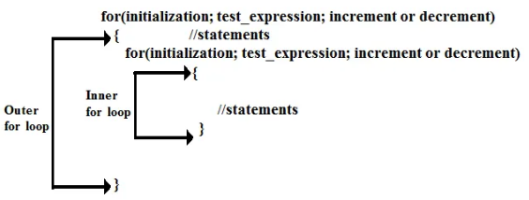
Figure 2: Structure of Nested For Loop

Nested For Loop Flowchart
Initially, nested for loop evaluates outer for loop test expression and evaluates only once. If the condition is true, the flow of control jumps to the inner for loop.
Then, the loop evaluates the condition of the inner loop. when the condition is true, it executes codes of inside the inner for loop. If the test expression returns false, the flow of control skips the execution and jumps out to the outer loop for execution.
Then the outer for loop test expression is evaluated again when the test expression is false, the flow of control skips the execution and come out of the loop for rest.
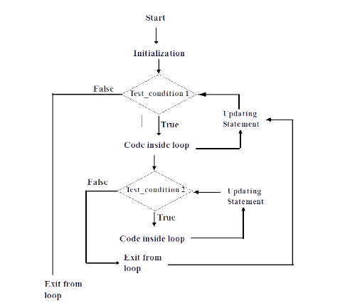
Figure 3: Flowchart of Nested-For-Loop

Example 1
Code | Output
#include <iostream>  Using namespace std;  int main()  {  int a,b;  for(a=1; a<=10; a++){  for(b=1; b<=10; b++){  cout<<b;  }  cout<<"\n";  }  return 0;  } | 12345678910  12345678910  12345678910  12345678910  12345678910  12345678910  12345678910  12345678910  12345678910  12345678910

Example 2
Code | Output
#include <iostream>  Using namespace std;  int main()  {  int i,j;  for(i=0; i<=2; i++){  cout<<i<<"Statement of outer for loop\n";  for(j=0; j<=3; j++){  cout<<i<<j;  cout<<": Statement of inner for loop\n";  }  }  return 0;  } | Statement of outer for loop  0 0 :Statement of inner for loop  0 1 :Statement of inner for loop  0 2 :Statement of inner for loop  0 3 :Statement of inner for loop  Statement of outer for loop  1 0 :Statement of inner for loop  1 1 :Statement of inner for loop  1 2 :Statement of inner for loop  1 3 :Statement of inner for loop  Statement of outer for loop  2 0 :Statement of inner for loop  2 1 :Statement of inner for loop  2 2 :Statement of inner for loop  2 3 :Statement of inner for loop

Example 3
Code | Output
#include <iostream>  Using namespace std;  int main()  {  int a,b;  for(a=1; a<=10; a++){  for(b=1; b<=10; b++){  cout<<"*”;  }  cout<<"\n";  }  return 0;  } | **********  **********  **********  **********  **********  **********  **********  **********  **********  **********

Lab Tasks

Connectivity Matrix (nested for)
Print an N × N reachability matrix for N nodes where cell (i,j) = 1 if i == j or (i+j) is even, else 0. Read N (≤ 8).
- Outer loop rows, inner loop columns.
- Align the 0/1 grid.
Goal: nested traversal of an adjacency-style matrix.
void connMatrix() { // Task B3
int N; cout<<"Enter N (<=8): "; cin>>N;
// TODO B3: nested for; print 1 if i==j or (i+j)%2==0 else 0 (setw(3))
}

Expected Output
N = 4:
1 0 1 0
0 1 0 1
1 0 1 0
0 1 0 1
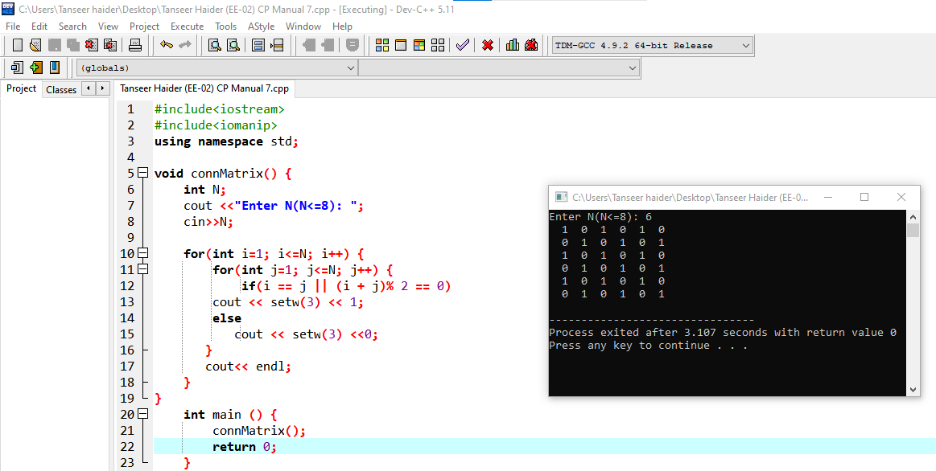

Home Assignment:
PWM Duty-Cycle Waveform Grid
A microcontroller drives 4 output channels, an LED dimmer, two DC motors, and a heater element using Pulse-Width Modulation (PWM). Each channel has its own duty cycle (% of time the signal is HIGH within one cycle). You will use nested loops to print each channel's PWM pattern across a 20-slot cycle, exactly the kind of waveform table used when verifying PWM timing on an oscilloscope or logic analyzer.

Concepts Covered in This Lab
- Nested for-loop structure: outer loop = channel, inner loop = time slot
- Using if / else-if inside the outer loop to assign a value per iteration
- Building a repeating 1/0 pattern with a conditional inside the inner loop
- Accumulating a count across the inner loop and reporting it after the loop ends
- Printing border/frame patterns around a nested-loop grid

Starter Code
Complete the TODO sections directly inside main().Every operation is written using loops and conditionals inside main().
#include <iostream>
#include <iomanip>
using namespace std;

int main() {
int totalChannels = 4;
int totalSlots = 20; // one full PWM cycle divided into 20 time slots

int ch, slot;
int dutyCycle; // percentage ON-time for the current channel
int onSlots; // number of slots that should be HIGH for this channel
int onCount; // counts how many slots were actually printed as ON

// ---------- TODO 1: Print a top border ----------
// Print a line of '=' characters, (totalSlots*2 + 12) characters long.

// ---------- TODO 2: Print the time-slot header ----------
// Using a single loop, print slot numbers 1 to totalSlots as a header row.

for (ch = 0; ch < totalChannels; ch++) {

// ---------- TODO 3: Assign a duty cycle to this channel ----------
// Channel 0 = 25% (LED dimmer) | Channel 1 = 50% (Motor A)
// Channel 2 = 75% (Motor B) | Channel 3 = 90% (Heater element)
// Use if / else if based on the value of ch to set dutyCycle.

onSlots = (dutyCycle * totalSlots) / 100;
onCount = 0;
cout << "CH" << ch << ": ";

// ---------- TODO 4: Print the PWM pattern for this channel ----------
// Inner loop from slot = 1 to totalSlots.
// If slot <= onSlots, print "1 " and increment onCount.
// Otherwise print "0 ".

// ---------- TODO 5: Report the ON-slot count ----------
// After the inner loop ends, print " -> ON slots: " followed by onCount.
cout << endl;
}

// ---------- TODO 6: Print a bottom border ----------
// Print the same '=' border line used in TODO 1.

return 0;
}

Sub-Tasks
Task 1: Frame and header
Print a top border line, then a header row numbering each of the 20 time slots. This is pure single-loop warm-up before the nested structure begins.
Task 2: Per-channel duty cycle assignment
Inside the outer loop (over channels), use if/else-if on the channel number to decide the correct duty cycle percentage — no arrays, just conditional branches based on the loop variable.
Task 3: Pattern generation
Inside the inner loop (over time slots), print '1' while the slot number is within the ON portion of the cycle, and '0' afterward — the classic nested-loop conditional-pattern technique.
Task 4: Counting within a loop
Track how many '1's you actually printed for each channel using an accumulator variable that resets at the start of every outer-loop iteration.
Task 5: Framing the whole grid
Add matching border lines above the header and below the last channel row so the output looks like a clean waveform table.

Expected Outcome
- A top and bottom border line of '=' characters framing the table.
- A header row showing slot numbers 1 through 20.
- CH0 shows 5 ones followed by 15 zeros (25% duty) with 'ON slots: 5'.
- CH1 shows 10 ones then 10 zeros (50%), CH2 shows 15 ones then 5 zeros (75%), CH3 shows 18 ones then 2 zeros (90%).
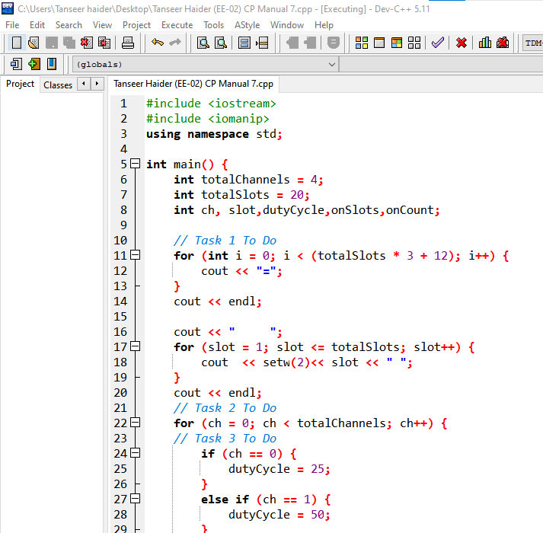
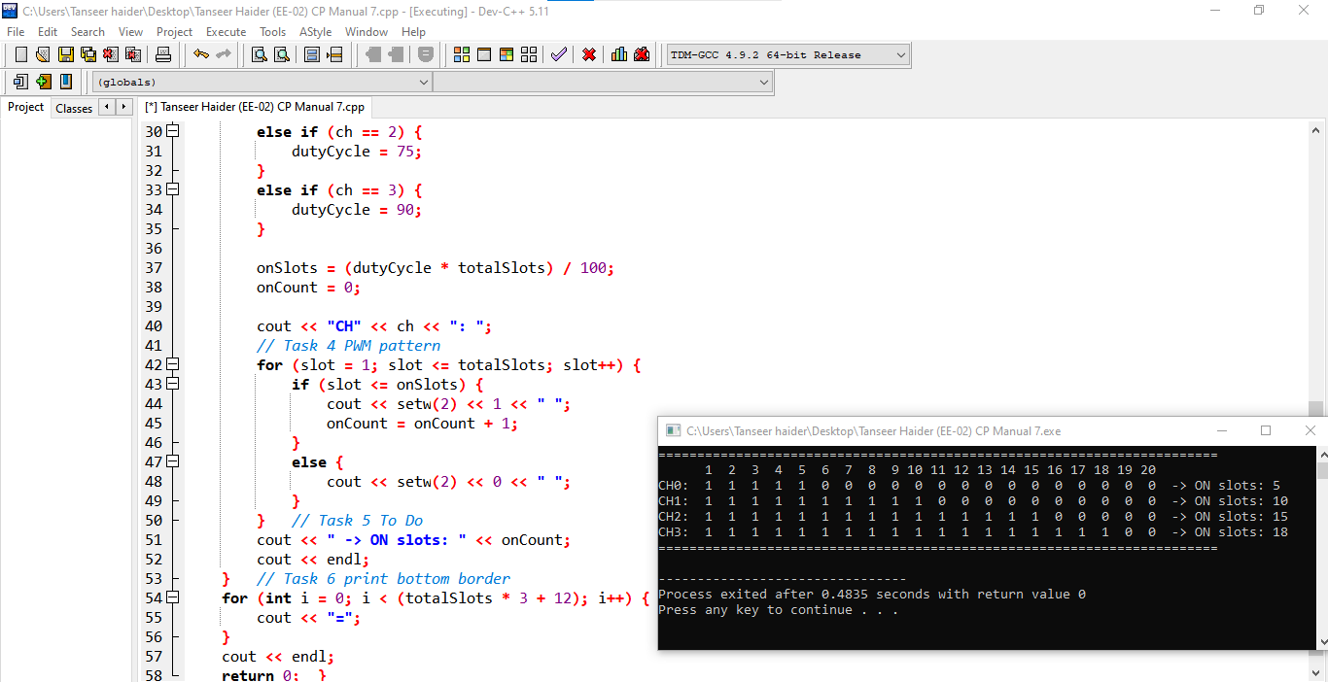

Hands-On Practice Exercises (Do Independently)
Write these as separate standalone programs, without referring back to the starter code, to confirm you have understood the concept on your own.
- Print an 8x8 grid where cell(row, col) = 1 if row == col (representing direct wire connections on a circuit board) and 0 otherwise.
- Ask the user for a number of amplifier stages and print a right-angled triangle of '*' with that many rows, representing a gain-staging diagram.
- Using nested loops (outer = voltage V from 1 to 5, inner = current I from 1 to 5), print a table of calculated power P = V × I for every V/I combination.

